Analysis For Events

Number of responses - 290

- 52% of businesses have seen revenue decline by over 50%
- 77% of businesses have seen revenue decline by over 20%

- Tourism Industry Average
52% of businesses have seen revenue decline by over 50%
74% of businesses have seen revenue decline by over 20%

- 43% of businesses have had cancellation rates of over 50% for Q1 2022

- Tourism Industry Average
29% of businesses have had cancellation rates of over 50% for Q1 2022

- 20% of businesses have booking levels more than 50% below pre-covid levels for Q1 2022
- 48% of businesses have booking levels at least 25% below pre-covid levels for Q1 2022

- Tourism Industry Average
24% of businesses have booking levels more than 50% below pre-covid levels for Q1 2022
49% of businesses have booking levels at least 25% below pre-covid levels for Q1 2022

- 21% of businesses have no cash reserves
- 49% of businesses have less than two months cash reserves

- Tourism Industry Average
26% of businesses have no cash reserves
55% of businesses have less than two months cash reserves

- 7.2% of businesses are very likely to fail
- 44.1% of businesses are at least likely to fail

- Tourism Industry Average
11.2% of businesses are very likely to fail
40.8% of businesses are at least likely to fail

Measures Needed (Average Score where 0 = it would make little difference and 10= make a big difference)

MEASURE SCORE Industry Average

Additional Sector Specific Grants 8.3 8.0

Removing Covid Restrictions 7.7 7.0

Retaining the 12.5% VAT Rate 4.9 5.8

Greater Government Clarity On Rules 6.9 6.8

Government Funding for Marketing Campaigns 5.0 4.1

Reintroduction of Furlough 6.8 6.3

Government Reassurance On The Safety Of Travel 7.0 6.8

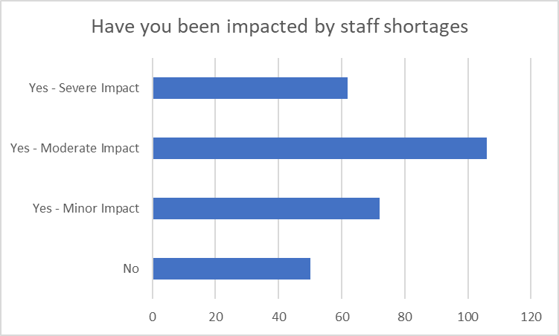

- 21% of businesses have been severely impacted by staff shortages
- 58% of businesses have been moderately or severely impacted by staff shortages

- Tourism Industry Average
17% of Businesses have been severely Impacted by Staff Shortages
45% of Businesses have been moderately or severely impacted by Staff Shortages

How Businesses Have Responded To Staff Shortages (1-10)

Events Tourism Average
- Employees have had to work increased hours 6.9 6.6
- We've had to recruit temporary workers 5.4 4.3
- We've had to reduce our hours or services 4.2 5.0
- We've had to pause trading entirely 3.0 3.0
- We've had to turn away business 5.2 5.1

- Our business has not been affected 2.4 2.6

- 20% of businesses say that staff turnover has increased by more than 20%
- 41% of businesses report staff turnover increasing while only 11% report it decreasing.

- Tourism Industry Average
24% of businesses say that Staff turnover has increased by more than 20%
45% of businesses report staff turnover increasing while only 9% report it decreasing

- 51% of businesses said the main reason for their financial difficulty was a reduction in revenue
- Only 1.5% of businesses said the main reason for their financial difficulty was increased costs

- Tourism Industry Average
44% of businesses said the main reason for their financial difficulty was the reduction in revenue
Only 3.6% of businesses said the main reason for their financial difficulty was increased costs

- 42% of business ranked Higher input and material costs and the main reason for increased costs
- 36% of businesses ranked Higher Staff Cost and the main reason for increased costs

- Tourism Industry Average
22% of business ranked Higher input and material costs and the main reason for increased costs
38% of businesses ranked Higher Staff Cost and the main reason for increased costs

- 50% of businesses say that the main reason for their reduced revenue is domestic travel and social distancing restrictions
- 23% of businesses say that the main reason for their reduced revenue is international travel restriction

- Tourism Industry Average
43% of businesses say that the main reason for their reduced revenue is domestic travel and social distancing restrictions
34% of businesses say that the main reason for their reduced revenue is international travel restriction

